EXP 1 : R AS CALCULATOR APPLICATION

- Using with and without R objects on console

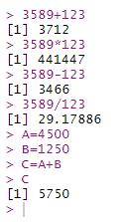

- Using mathematical functions on console

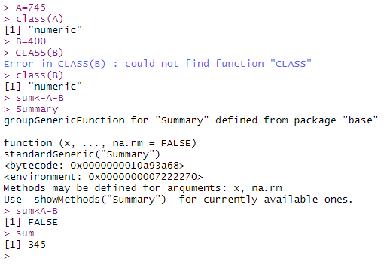
- Write an R script, to create R objects for calculator application and save in a specified location in disk
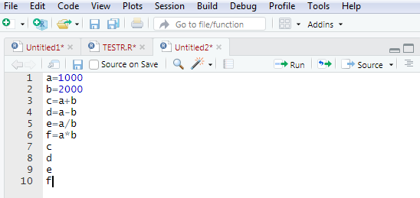
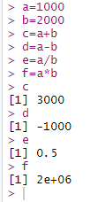

EXP2 -DESCRIPTIVE STATISTICS IN R

- Write an R script to find basic descriptive statistics using summary, str, quartile function on mtcars& cars datasets.

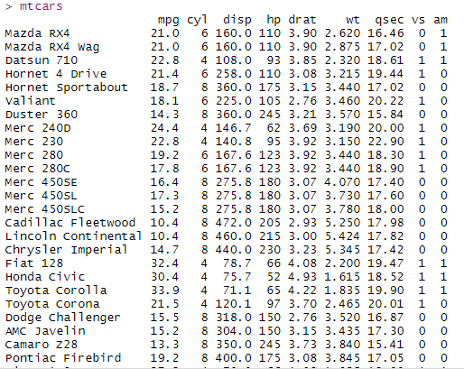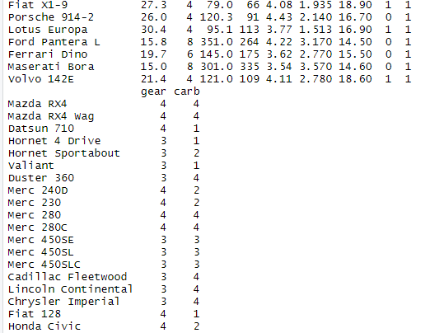

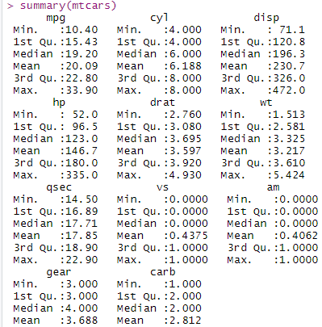

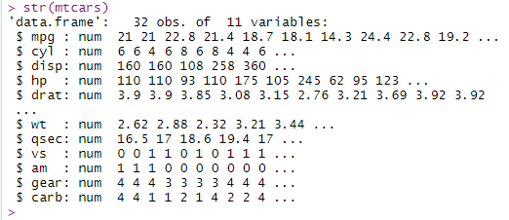

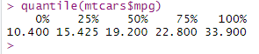
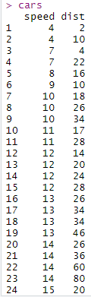
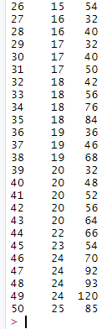
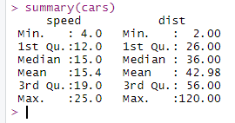

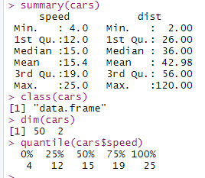

b . Write an R script to find subset of dataset by using subset (), aggregate () functions on iris dataset.

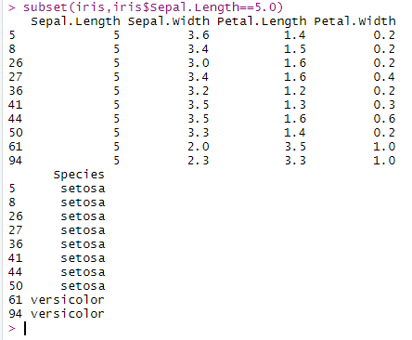

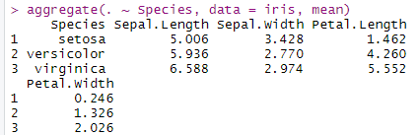

EXP 3 - READING AND WRITING DIFFERENT TYPES OF DATASETS

- Reading different types of data sets (.txt, .csv) from web and disk and writing in file in specific disk location.

1. OPEN EXCEL TO CREATE .CSV AND .TXT FILES CALLED empdet.csv and empdet.txt and save them in D:
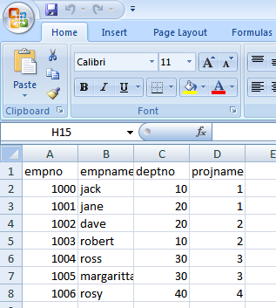

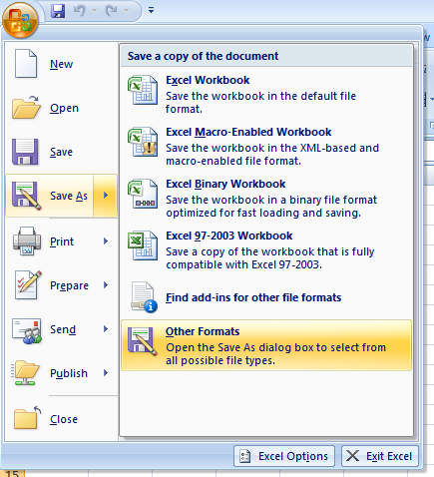
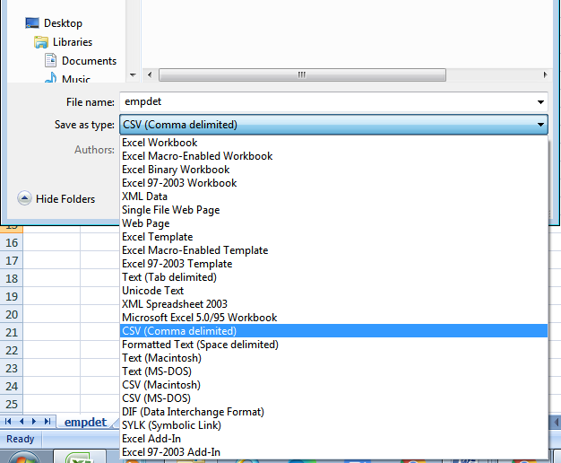

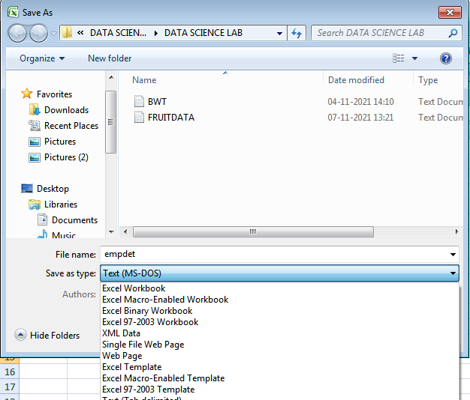

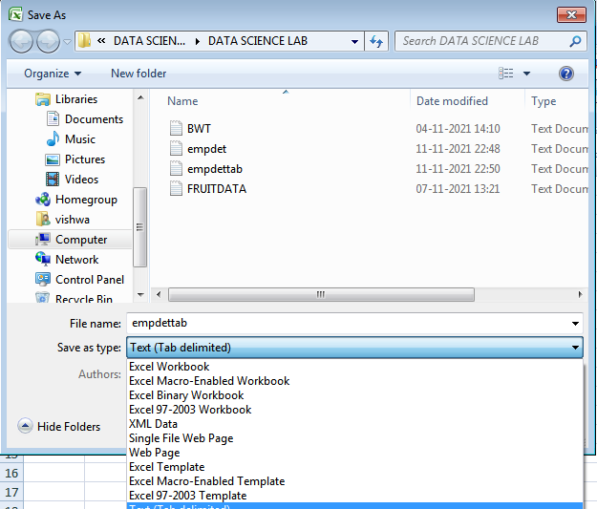

Installing and loading readr
# Installing
install.packages("readr")
# Loading
library("readr")

The readr package contains functions for reading i) delimited files, ii) lines and iii) the whole file.

Functions for reading delimited files: txt|csv
The function read_delim()[in readr package] is a general function to import a data table into R. Depending on the format of your file, you can also use:

- read_csv(): to read a comma (“,”) separated values
- read_csv2(): to read a semicolon (“;”) separated values
- read_tsv(): to read a tab separated (“\t”) values

The simplified format of these functions are, as follow:
# General function
read_delim(file, delim, col_names = TRUE)
# Read comma (",") separated values
read_csv(file, col_names = TRUE)
# Read semicolon (";") separated values
# (this is common in European countries)
read_csv2(file, col_names = TRUE)

# Read tab separated values
read_tsv(file, col_names = TRUE)

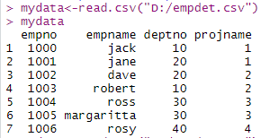

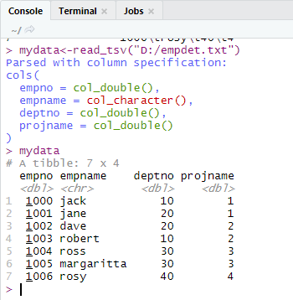

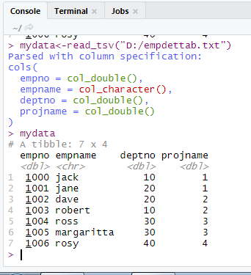

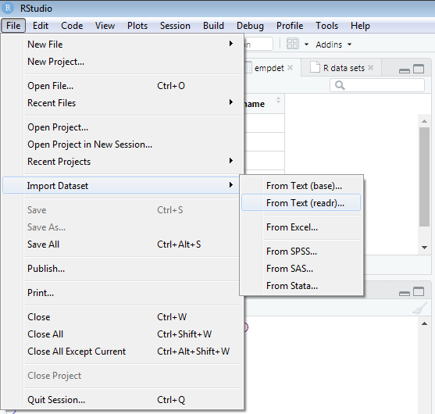
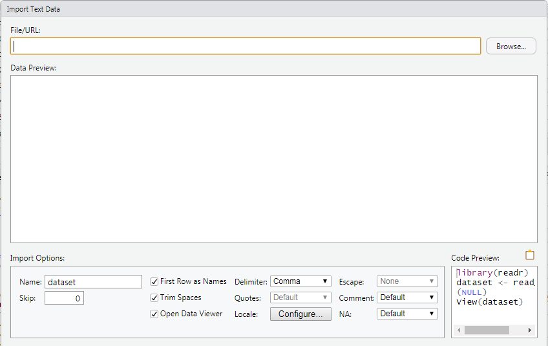

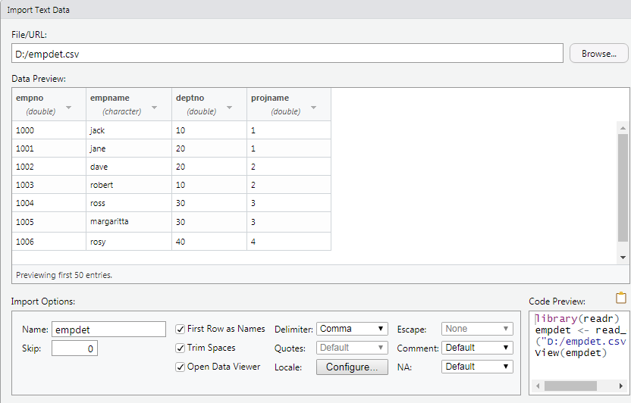
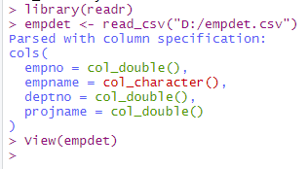
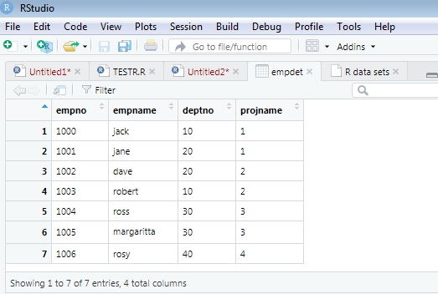

Reading a file from internet
It’s possible to use the functions read_delim(), read_csv() and read_tsv() to import files from the web.

my_data<- read_tsv("http://www.sthda.com/upload/boxplot_format.txt")

head(my_data)

Nom variable Group
1 IND1 10 A
2 IND2 7 A
3 IND3 20 A
4 IND4 14 A
5 IND5 14 A
6 IND6 12 A

TO WRITE DATA INTO A FILE:
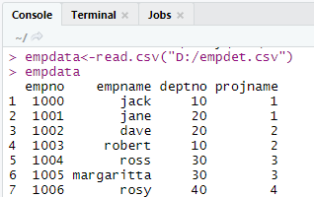
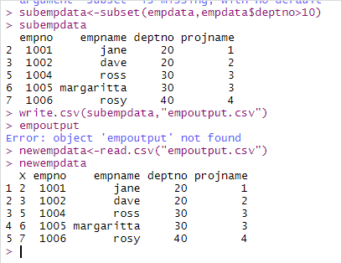

b. Reading Excel data sheet in R.

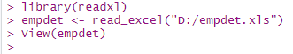

EXP 4 – VISUALIZATIONS

  - Find the data distributions using box and scatter plot.

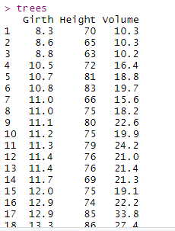

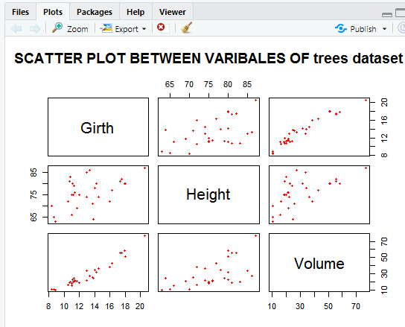

pch=plot character ,defines the point symbols in the functions plot() and lines(). It contains numeric values ranges from 0 to 25 or character symbols ("+","-"....) SPECIFYING POINT SYMBOLS OR SHAPES.
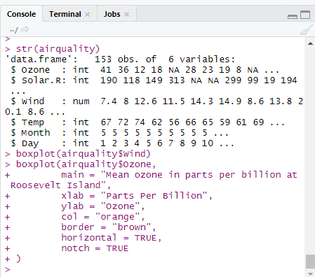
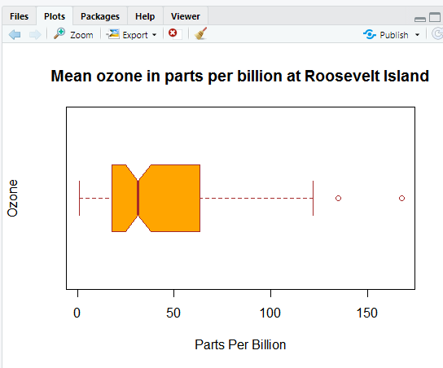

Find the outliers using plot.

v=c(50,75,100,125,150,175,200)
boxplot(v)

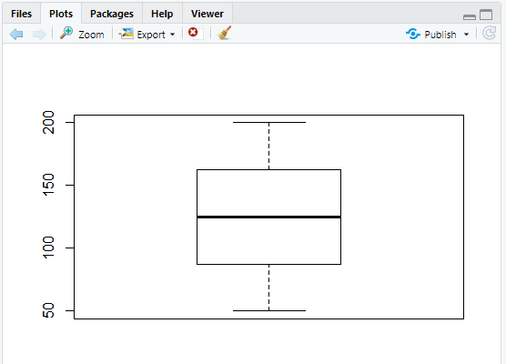

Plot the histogram, bar chart and pie chart on sample data.

Histogram

library(graphics)
v <- c(9,13,21,8,36,22,12,41,31,33,19)

# Create the histogram.
hist(v,xlab = "Weight",col = "blue",border = "green")

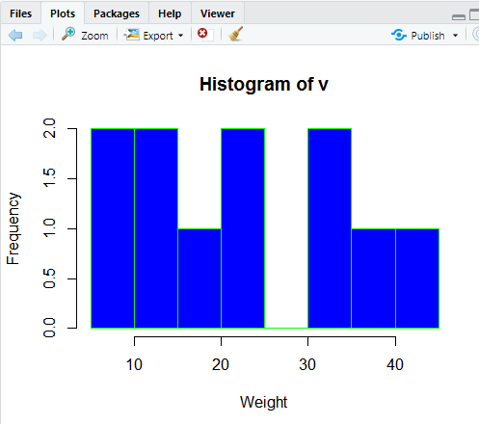

Bar chart

library(graphics)
H <- c(7,12,28,3,41)
M <- c("Jan","Feb","Mar","Apr","May")
# Plot the bar Chart.
barplot(H,names.arg = M,xlab = "Month",ylab = "Revenue",col = "blue",main = "Revenue chart",border
= "red")

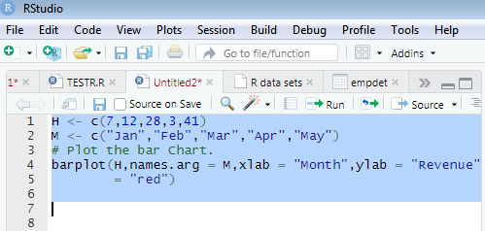

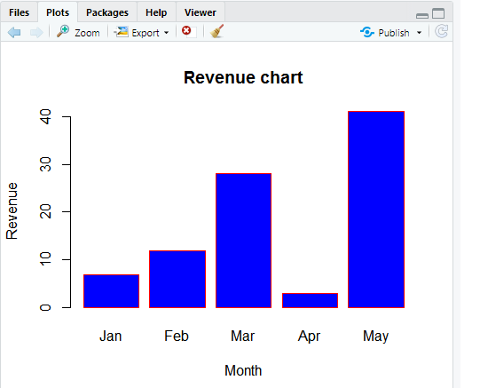

Pie Chart

library(graphics)

x <- c(21, 62, 10, 53)

labels<- c("London", "NewYork", "Singapore", "Mumbai")

# Plot the Pie chart.

pie(x,labels)

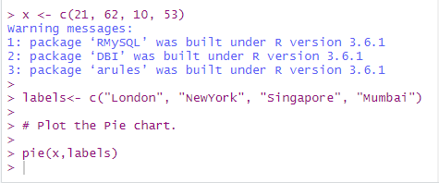
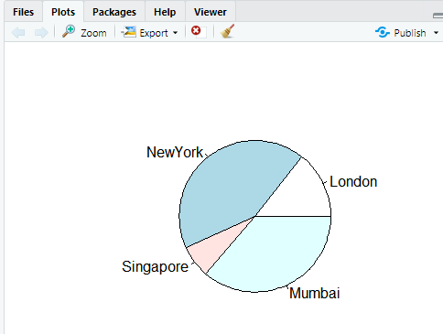

EXP-5 CORRELATION AND COVARIANCE

# Load data
data("mtcars")

my_data <- mtcars[, c(1,3,4,5,6,7)]

# print the first 6 rows
head(my_data, 6)

mpg disp hp drat wt qsec
Mazda RX4 21.0 160 110 3.90 2.620 16.46
Mazda RX4 Wag 21.0 160 110 3.90 2.875 17.02
Datsun 710 22.8 108 93 3.85 2.320 18.61
Hornet 4 Drive 21.4 258 110 3.08 3.215 19.44
Hornet Sportabout 18.7 360 175 3.15 3.440 17.02
Valiant 18.1 225 105 2.76 3.460 20.22

Compute correlation matrix
res <- cor(my_data)
round(res, 2)

mpg disp hp drat wt qsec
mpg 1.00 -0.85 -0.78 0.68 -0.87 0.42
disp -0.85 1.00 0.79 -0.71 0.89 -0.43
hp -0.78 0.79 1.00 -0.45 0.66 -0.71
drat 0.68 -0.71 -0.45 1.00 -0.71 0.09
wt -0.87 0.89 0.66 -0.71 1.00 -0.17
qsec 0.42 -0.43 -0.71 0.09 -0.17 1.00

In the table above correlations coefficients between the possible pairs of variables are shown. We will use Hmisc R package to calculate the correlation p-values.

Correlation matrix with significance levels (p-value)
The function rcorr() [in Hmisc package] can be used to compute the significance levels for pearson and spearman correlations. It returns both the correlation coefficients and the p-value of the correlation for all possible pairs of columns in the data table.

- Simplified format:
rcorr(x, type = c("pearson","spearman"))

x should be a matrix. The correlation type can be either pearson or spearman.

- Install Hmisc package:
install.packages("Hmisc")

- Use rcorr() function
library("Hmisc")
res2 <- rcorr(as.matrix(my_data))
res2

mpg disp hp drat wt qsec
mpg 1.00 -0.85 -0.78 0.68 -0.87 0.42
disp -0.85 1.00 0.79 -0.71 0.89 -0.43
hp -0.78 0.79 1.00 -0.45 0.66 -0.71
drat 0.68 -0.71 -0.45 1.00 -0.71 0.09
wt -0.87 0.89 0.66 -0.71 1.00 -0.17
qsec 0.42 -0.43 -0.71 0.09 -0.17 1.00
n= 32
P
mpg disp hp drat wt qsec
mpg 0.0000 0.0000 0.0000 0.0000 0.0171
disp 0.0000 0.0000 0.0000 0.0000 0.0131
hp 0.0000 0.0000 0.0100 0.0000 0.0000
drat 0.0000 0.0000 0.0100 0.0000 0.6196
wt 0.0000 0.0000 0.0000 0.0000 0.3389
qsec 0.0171 0.0131 0.0000 0.6196 0.3389

The output of the function rcorr() is a list containing the following elements : - r : the correlation matrix - n : the matrix of the number of observations used in analyzing each pair of variables - P : the p-values corresponding to the significance levels of correlations.

If you want to extract the p-values or the correlation coefficients from the output, use this:
# Extract the correlation coefficients
res2$r

# Extract p-values
res2$P

Visualize correlation matrix
There are different ways for visualizing a correlation matrix in R software :
- symnum() function
- corrplot() function to plot a correlogram
- scatter plots
- heatmap

Use corrplot() function: Draw a correlogram
The function corrplot(), in the package of the same name, creates a graphical display of a correlation matrix, highlighting the most correlated variables in a data table.

In this plot, correlation coefficients are colored according to the value. Correlation matrix can be also reordered according to the degree of association between variables.
- Install corrplot:
install.packages("corrplot")

- Use corrplot() to create a correlogram:

The function corrplot() takes the correlation matrix as the first argument. The second argument (type=“upper”) is used to display only the upper triangular of the correlation matrix.

library(corrplot)
corrplot(res, type = "upper", order = "hclust", tl.col = "black", tl.srt = 45)
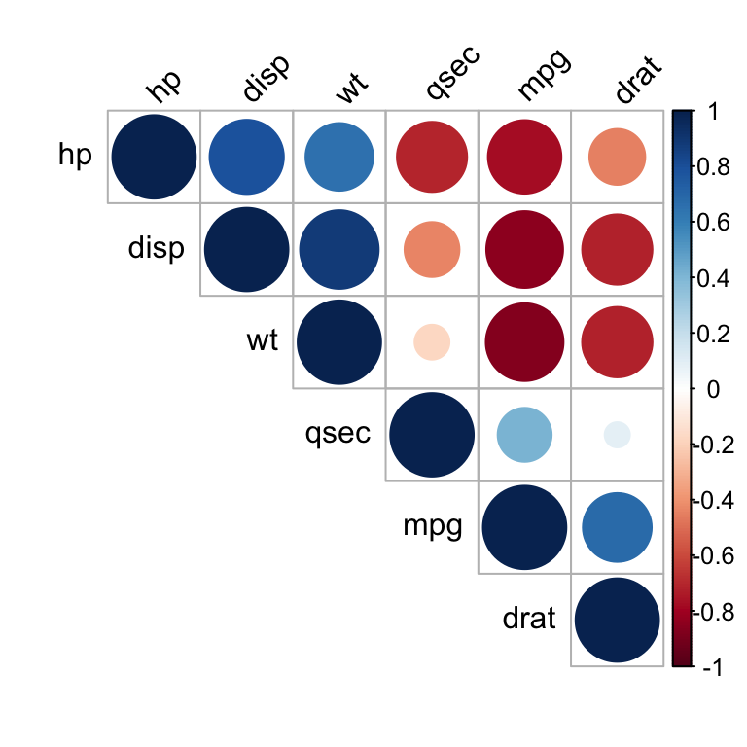
Positive correlations are displayed in blue and negative correlations in red color. Color intensity and the size of the circle are proportional to the correlation coefficients. In the right side of the correlogram, the legend color shows the correlation coefficients and the corresponding colors.

- The correlation matrix is reordered according to the correlation coefficient using “hclust” method.
- tl.col (for text label color) and tl.srt (for text label string rotation) are used to change text colors and rotations.
- Possible values for the argument type are : “upper”, “lower”, “full”

It’s also possible to combine correlogram with the significance test. We’ll use the result res.cor2 generated in the previous section with rcorr() function [in Hmisc package]:

# Insignificant correlation are crossed
corrplot(res2$r, type="upper", order="hclust",p.mat = res2$P, sig.level = 0.01, insig = "blank")

# Insignificant correlations are leaved blank
corrplot(res2$r, type="upper", order="hclust",p.mat = res2$P, sig.level = 0.01, insig = "blank")
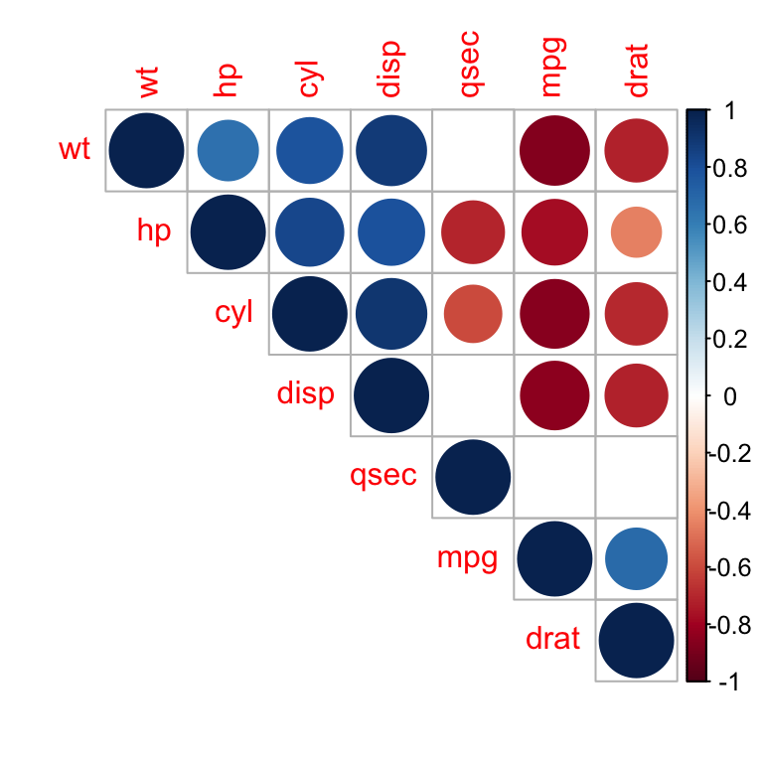
In the above plot, correlations with p-value > 0.01 are considered as insignificant. In this case the correlation coefficient values are leaved blank or crosses are added.

Use chart.Correlation(): Draw scatter plots
The function chart.Correlation()[ in the package PerformanceAnalytics], can be used to display a chart of a correlation matrix.

- Install PerformanceAnalytics:
install.packages("PerformanceAnalytics")

- Use chart.Correlation():

library("PerformanceAnalytics")

my_data <- mtcars[, c(1,3,4,5,6,7)]

chart.Correlation(my_data, histogram=TRUE, pch=19)
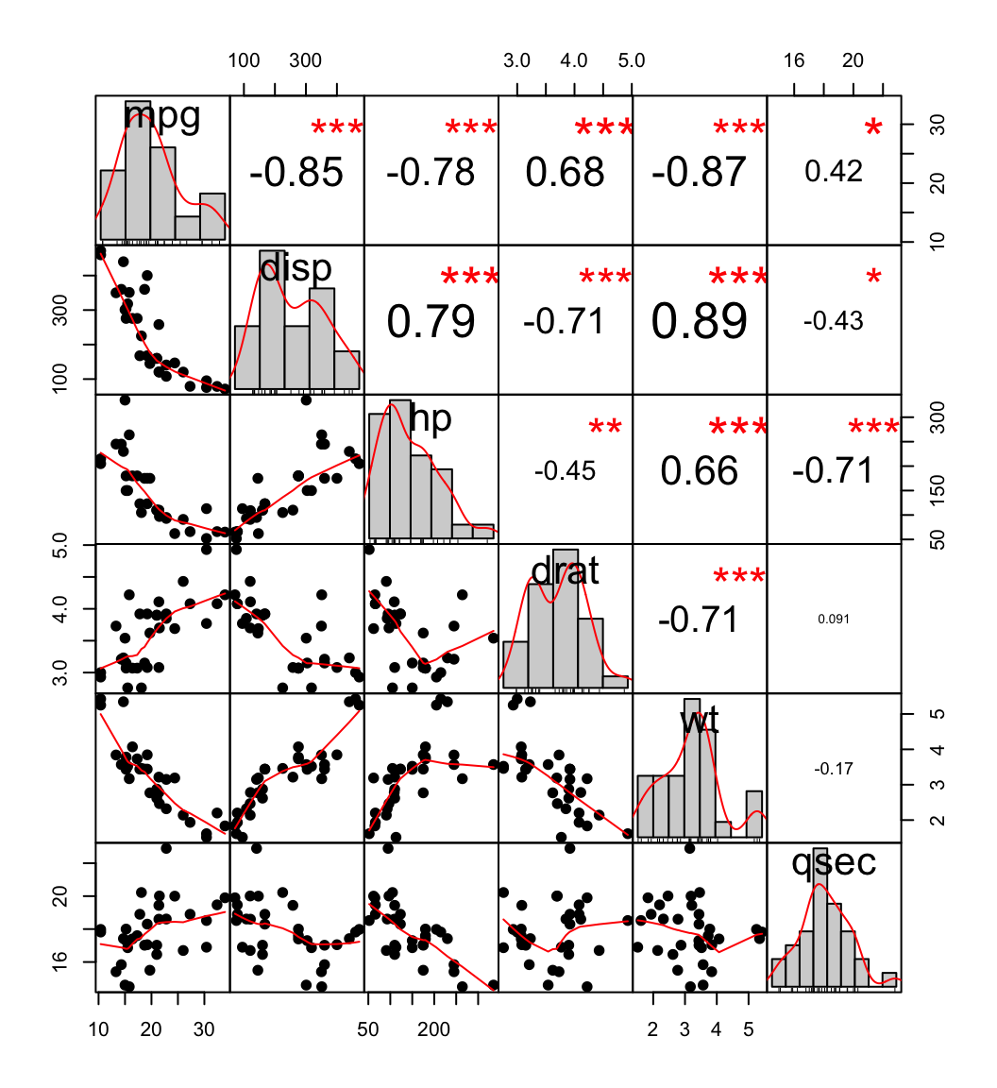

In the above plot:
- The distribution of each variable is shown on the diagonal.
- On the bottom of the diagonal : the bivariate scatter plots with a fitted line are displayed
- On the top of the diagonal : the value of the correlation plus the significance level as stars
- Each significance level is associated to a symbol : p-values(0, 0.001, 0.01, 0.05, 0.1, 1) <=> symbols(“***”, “**”, “*”, “.”, " “)

Use heatmap()
# Get some colors
col<- colorRampPalette(c("blue", "white", "red"))(20)
heatmap(x = res, col = col, symm = TRUE)
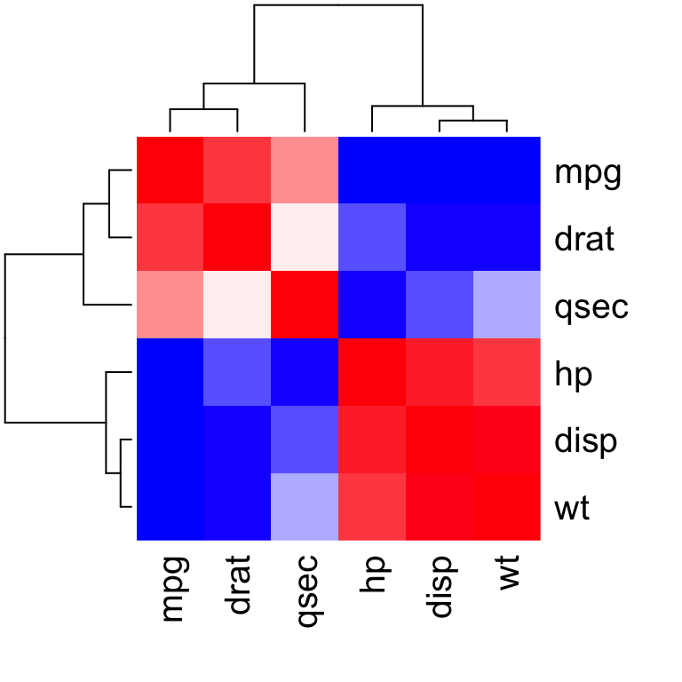

- x : the correlation matrix to be plotted
- col : color palettes
- symm : logical indicating if x should be treated symmetrically; can only be true when x is a square matrix.

COVARIANCE

> a <- c(1,2,3,4,5,6)
> b <- c(2,3,5,6,1,9)
> c <- c(3,5,5,5,10,8)
> d <- c(10,20,30,40,50,55)
> e <- c(7,8,9,4,6,10)
> M <- cbind(a,b,c,d,e)
> M
a b c d e
[1,] 1 2 3 10 7
[2,] 2 3 5 20 8
[3,] 3 5 5 30 9
[4,] 4 6 5 40 4
[5,] 5 1 10 50 6
[6,] 6 9 8 55 10
> cov(M)
a b c d e
a 3.5 3.000000 4.0 32.500000 0.400000
b 3.0 8.666667 0.4 25.333333 2.466667
c 4.0 0.400000 6.4 38.000000 0.400000
d 32.5 25.333333 38.0 304.166667 1.333333
e 0.4 2.466667 0.4 1.333333 4.666667
EXP 6 : REGRESSION MODEL
Logistic regression, also called a logit model. In the logit model the log odds of the outcome is modelled as a linear combination of the predictor variables.
A researcher is interested in how variables, such as GRE (Graduate Record Exam scores), GPA (grade point average) and prestige of the undergraduate institution, effect admission into graduate school. The response variable, admit/don’t admit, is a binary variable.

> mydata<-read.csv("D:/binary.csv")

> head(mydata)
## admit gre gpa rank
## 1 0 380 3.61 3
## 2 1 660 3.67 3
## 3 1 800 4.00 1
## 4 1 640 3.19 4
## 5 0 520 2.93 4
## 6 1 760 3.00 2
This dataset has a binary response (outcome, dependent) variable called admit. There are three predictor variables: gre, gpa and rank. We will treat the variables gre and gpa as continuous. The variable rank takes on the values 1 through 4. Institutions with a rank of 1 have the highest prestige, while those with a rank of 4 have the lowest. We can get basic descriptive for the entire data set by using summary.

summary(mydata)
## admit gre gpa rank
## Min. :0.000 Min. :220 Min. :2.26 Min. :1.00
## 1st Qu.:0.000 1st Qu.:520 1st Qu.:3.13 1st Qu.:2.00
## Median :0.000 Median :580 Median :3.40 Median :2.00
## Mean :0.318 Mean :588 Mean :3.39 Mean :2.48
## 3rd Qu.:1.000 3rd Qu.:660 3rd Qu.:3.67 3rd Qu.:3.00
## Max. :1.000 Max. :800 Max. :4.00 Max. :4.00

Using the logit model
The code below estimates a logistic regression model using the glm (generalized linear model) function..
mylogit <- glm(admit ~ gre + gpa + rank, data = mydata, family = "binomial")
> mylogit

Call: glm(formula = admit ~ gre + gpa + rank, family = "binomial",
data = mydata)

Coefficients:
(Intercept) gre gpa rank
-3.449548 0.002294 0.777014 -0.560031

Degrees of Freedom: 399 Total (i.e. Null); 396 Residual
Null Deviance: 500
Residual Deviance: 459.4 AIC: 467.4

EXP 7: CLASSIFICATION MODEL
Decision Trees with Package rpart

Package rpart is used to build a decision tree on the bodyfat data . Function rpart() is used to build a decision tree,and the tree with the minimum prediction error is selected. After that, it is applied to new data to make prediction with function predict().

we load the bodyfat data and have a look at it.

> library(rpart)

> data("bodyfat", package = "TH.data")

> library(TH.data)
Loading required package: survival
Attaching package: ‘TH.data’
The following object is masked from ‘package:MASS’:
geyser
Warning message:
package ‘TH.data’ was built under R version 3.6.1

> data("bodyfat", package = "TH.data")

> dim(bodyfat)
[1] 71 10

> attributes(bodyfat)
$names
[1] "age" "DEXfat" "waistcirc"
[4] "hipcirc" "elbowbreadth" "kneebreadth"
[7] "anthro3a" "anthro3b" "anthro3c"
[10] "anthro4"

$row.names
[1] "47" "48" "49" "50" "51" "52" "53" "54" "55"
[10] "56" "57" "58" "59" "60" "61" "62" "63" "64"
[19] "65" "66" "67" "68" "69" "70" "71" "72" "73"
[28] "74" "75" "76" "77" "78" "79" "80" "81" "82"
[37] "83" "84" "85" "86" "87" "88" "89" "90" "91"
[46] "92" "93" "94" "95" "96" "97" "98" "99" "100"
[55] "101" "102" "103" "104" "105" "106" "107" "108" "109"
[64] "110" "111" "112" "113" "114" "115" "116" "117"

$class
[1] "data.frame"

> bodyfat[1:5,]
age DEXfat waistcirc hipcirc elbowbreadth kneebreadth
47 57 41.68 100.0 112.0 7.1 9.4
48 65 43.29 99.5 116.5 6.5 8.9
49 59 35.41 96.0 108.5 6.2 8.9
50 58 22.79 72.0 96.5 6.1 9.2
51 60 36.42 89.5 100.5 7.1 10.0
anthro3a anthro3b anthro3c anthro4
47 4.42 4.95 4.50 6.13
48 4.63 5.01 4.48 6.37
49 4.12 4.74 4.60 5.82
50 4.03 4.48 3.91 5.66
51 4.24 4.68 4.15 5.91

Next, the data is split into training and test subsets, and a decision tree is built on the training data.

> set.seed(1234)

> ind <- sample(2, nrow(bodyfat), replace=TRUE, prob=c(0.7, 0.3))

> bodyfat.train <- bodyfat[ind==1,]

> bodyfat.test <- bodyfat[ind==2,]

> # train a decision tree
> library(rpart)
> myFormula <- DEXfat ~ age + waistcirc + hipcirc + elbowbreadth + kneebreadth

>bodyfat_rpart<-rpart(myFormula,data=bodyfat.train,control=rpart.control(minsplit = 10))

> print(bodyfat_rpart$cptable)

CP nsplit rel error xerror xstd
1 0.67272638 0 1.00000000 1.0427457 0.19016187
2 0.09390665 1 0.32727362 0.5081173 0.11702581
3 0.06037503 2 0.23336696 0.4522296 0.09801847
4 0.03420446 3 0.17299193 0.3967005 0.09676249
5 0.01708278 4 0.13878747 0.3015476 0.07385485
6 0.01695763 5 0.12170469 0.2929969 0.06850104
7 0.01007079 6 0.10474706 0.2713231 0.06690466
8 0.01000000 7 0.09467627 0.2713231 0.06690466

> plot(bodyfat_rpart)

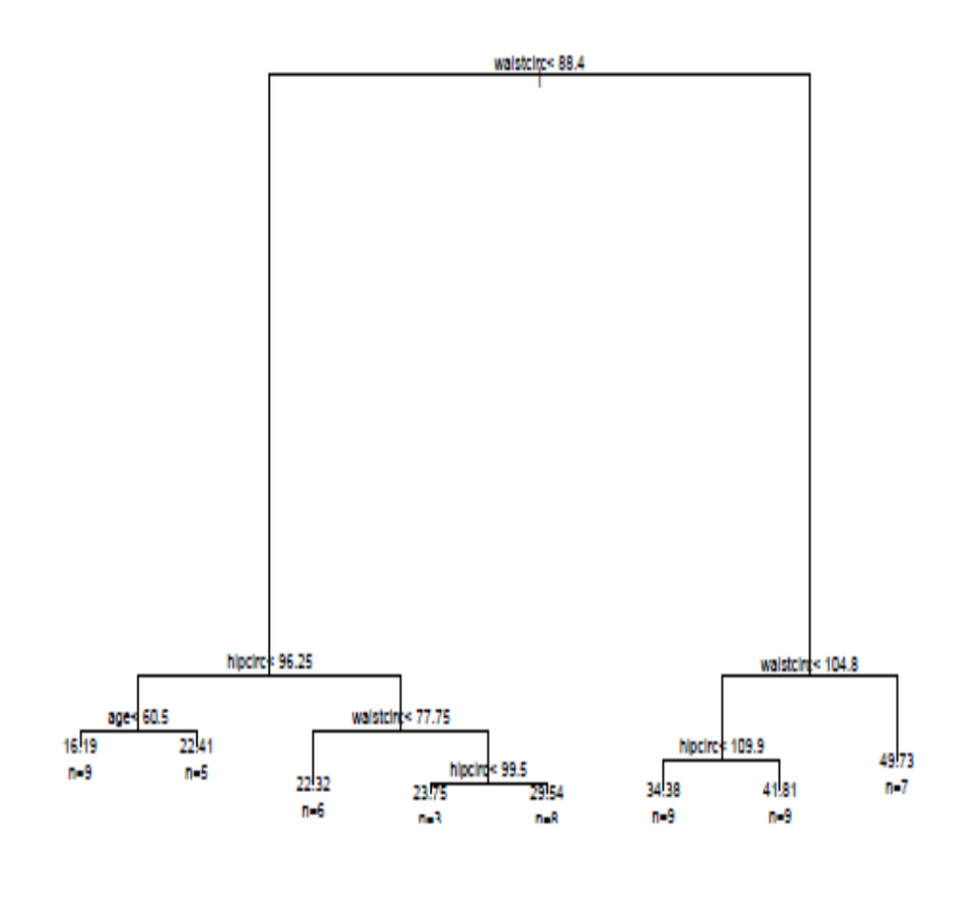

EXP 8 : CLUSTERING MODEL
Clustering in R refers to the assimilation of the same kind of data in groups or clusters to distinguish one group from the others(gathering of the same type of data). This can be represented in graphical format through R. We use the KMeans model in this process.

What is the K Means algorithm? K Means is a clustering algorithm that repeatedly assigns a group amongst k groups present to a data point according to the features of the point. It is a centroid-based clustering method.The number of clusters is decided, cluster centers are selected in random farthest from one another, the distance between each data point and center is calculated using Euclidean distance, the data point is assigned to the cluster whose center is nearest to that point. This process is repeated until the center of clusters does not change and data points remain in the same cluster.

Step 1: The Iris dataset which is an inbuilt dataset in R using the Cluster package is used. It has 5 columns namely – Sepal length, Sepal width, Petal Length, Petal Width, and Species. Iris is a flower and here in this dataset 3 of its species Setosa, Versicolor, Verginica are mentioned. We will cluster the flowers according to their species.
> data(iris)

> head(iris) #will show top 6 rows only

Sepal.Length Sepal.Width Petal.Length
1 5.1 3.5 1.4
2 4.9 3.0 1.4
3 4.7 3.2 1.3
4 4.6 3.1 1.5
5 5.0 3.6 1.4
6 5.4 3.9 1.7
Petal.Width Species
1 0.2 setosa
2 0.2 setosa
3 0.2 setosa
4 0.2 setosa
5 0.2 setosa
6 0.4 setosa
Step 2: The next step is to separate the 3rd and 4th columns into separate object x. As we are using the unsupervised learning method,we are removing labels so that the huge input of petal length and petal width columns will be used by the machine to perform clustering unsupervised.

> x=iris[,3:4] #using only petal length and width columns

> head(x)

Petal.Length Petal.Width
1 1.4 0.2
2 1.4 0.2
3 1.3 0.2
4 1.5 0.2
5 1.4 0.2
6 1.7 0.4
>

Step 3: The next step is to use the K Means algorithm. K Means is the method we use which has parameters (data, no. of clusters or groups). Here our data is the x object and we will have k=3 clusters as there are 3 species in the dataset.
Then the ‘cluster’ package is called. Clustering in R is done using this inbuilt package which will perform all the mathematics. Clusplot function creates a 2D graph of the clusters.
> model=kmeans(x,3)

> model

K-means clustering with 3 clusters of sizes 52, 50, 48

Cluster means:
Petal.Length Petal.Width
1 4.269231 1.342308
2 1.462000 0.246000
3 5.595833 2.037500

Clustering vector:
[1] 2 2 2 2 2 2 2 2 2 2 2 2 2 2 2 2 2 2 2 2 2 2 2 2 2 2 2 2 2
[30] 2 2 2 2 2 2 2 2 2 2 2 2 2 2 2 2 2 2 2 2 2 1 1 1 1 1 1 1 1
[59] 1 1 1 1 1 1 1 1 1 1 1 1 1 1 1 1 1 1 1 3 1 1 1 1 1 3 1 1 1
[88] 1 1 1 1 1 1 1 1 1 1 1 1 1 3 3 3 3 3 3 1 3 3 3 3 3 3 3 3 3
[117] 3 3 3 1 3 3 3 3 3 3 1 3 3 3 3 3 3 3 3 3 3 3 1 3 3 3 3 3 3
[146] 3 3 3 3 3

Within cluster sum of squares by cluster:
[1] 13.05769 2.02200 16.29167
(between_SS / total_SS = 94.3 %)

Available components:

[1] "cluster" "centers" "totss" "withinss"
[5] "tot.withinss" "betweenss" "size" "iter"
[9] "ifault"

> library(cluster)
> clusplot(x,model$cluster)
>

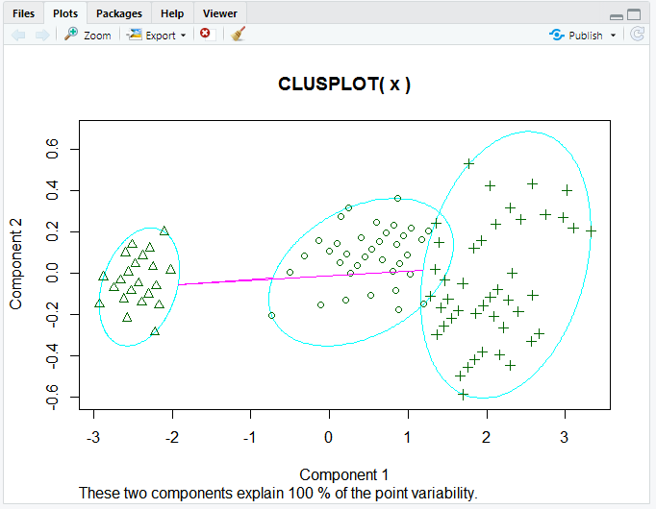
Component 1 and Component 2 seen in the graph are the two components in PCA (Principal Component Analysis) which is basically a feature extraction method that uses the important components and removes the rest. It reduces the dimensionality of the data for easier KMeans application. All of this is done by the cluster package itself in R.These two components explain 100% variability in the output which means the data object x fed to PCA was precise enough to form clear clusters using KMeans and there is minimum (negligible) overlapping amongst them.

Step 4: The next step is to assign different colors to the clusters and shading them hence we use the color and shade parameters setting them to T which means true.
> clusplot(x,model$cluster,color=TRUE,shade=TRUE)
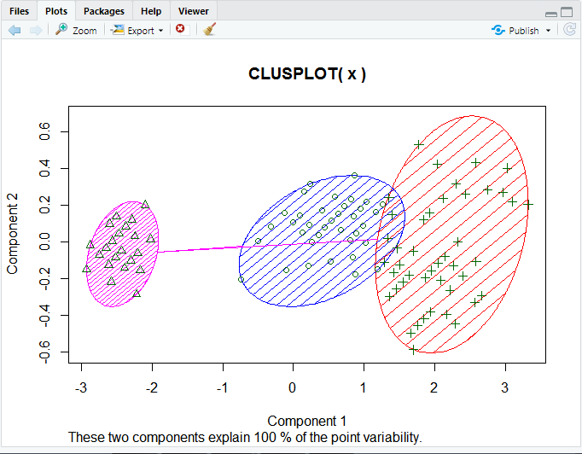
Hierarchical Clustering: R programming language provides a function hclust() for hierarchical clustering on a distance matrix. dist() function is used that generates the distance matrix.

> d <- dist(as.matrix(mtcars)) # find distance matrix

> hc <- hclust(d) # apply hierarchical clustering

> plot(hc) # plot the dendrogram

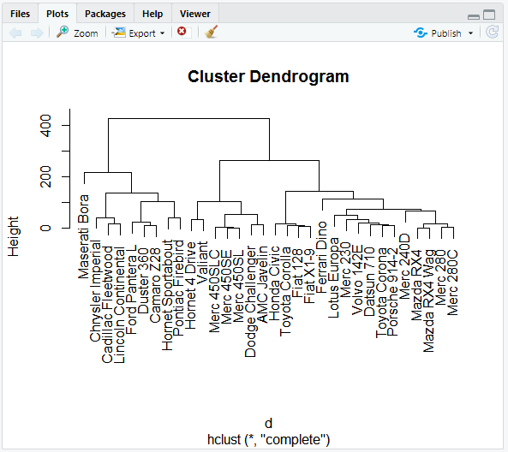
> mt<-Matrix(1:100,10,10)
Warning messages:
1: package ‘RMySQL’ was built under R version 3.6.1
2: package ‘DBI’ was built under R version 3.6.1
> mt
10 x 10 Matrix of class "dgeMatrix"
[,1] [,2] [,3] [,4] [,5] [,6] [,7] [,8]
[1,] 1 11 21 31 41 51 61 71
[2,] 2 12 22 32 42 52 62 72
[3,] 3 13 23 33 43 53 63 73
[4,] 4 14 24 34 44 54 64 74
[5,] 5 15 25 35 45 55 65 75
[6,] 6 16 26 36 46 56 66 76
[7,] 7 17 27 37 47 57 67 77
[8,] 8 18 28 38 48 58 68 78
[9,] 9 19 29 39 49 59 69 79
[10,] 10 20 30 40 50 60 70 80
[,9] [,10]
[1,] 81 91
[2,] 82 92
[3,] 83 93
[4,] 84 94
[5,] 85 95
[6,] 86 96
[7,] 87 97
[8,] 88 98
[9,] 89 99
[10,] 90 100

> ed<-dist(mt,method="eucledian")
Error in dist(mt, method = "eucledian") : invalid distance method
> ed<-dist(mt,method="euclidean")
> h1<-hclust(ed)
> h1
Call:
hclust(d = ed)
Cluster method : complete
Distance : euclidean
Number of objects: 10
> plot(h1)
>

